Employee has left the business since "Date_Left_Company__c"

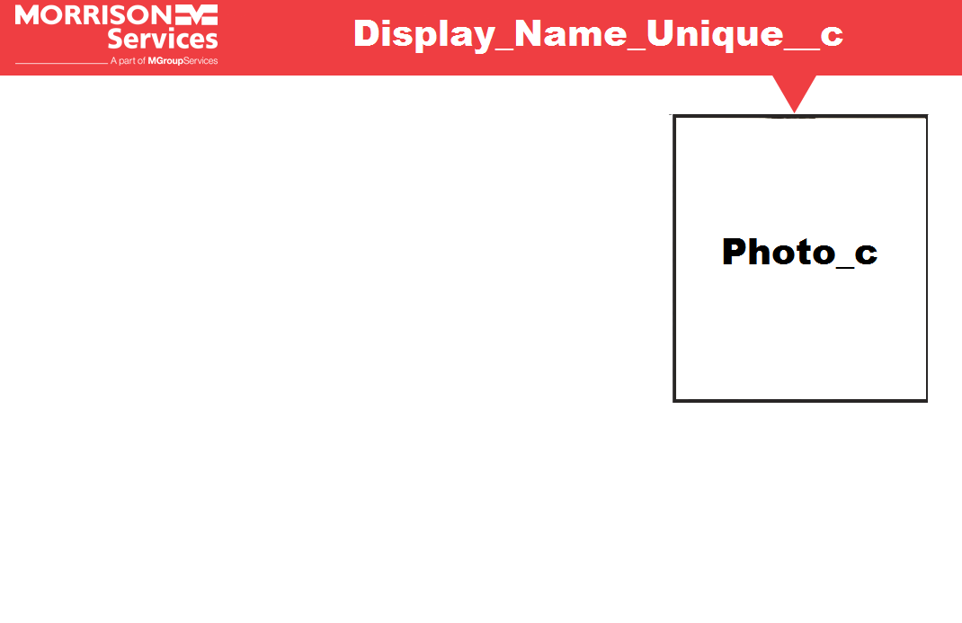

Morrison Telecom Services or Magdalene Logo dependant on what card it is

Information